22.18: Draw a cylindrical Gaussian surface with the line of charge as its axis. The cylinder has radius 0.400 m and is 0.0200 m long. The electric field is then 840 N/C at every point on the cylindrical surface and directed perpendicular to the surface. Thus
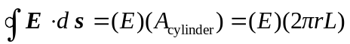
The field is parallel to the end caps of the cylinder, so for them 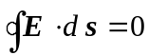. From Gauss’s law:
